

28
Target: ___/28 or ____ %

Year 9 HASS- Geography

40

40
Task 5 Part A: In Class Assessment Fieldwork Theory
And Skills Assessment (2.5 % weighting)
Reading Time: 5 minutes & Working Time: 35 minutes

Name: Teacher:

- What type of photograph is Source 3? (1 mark)

______________________________________________________________________

- Describe what is shown in Source 1. Consider cultural (built) features and natural (physical) features. (4 marks)

______________________________________________________________________________________________________________________________________________________________________________________________________________________________________________________________________________________________________________________________________________________________
__________________________________________________________________________________________________________________________________________________________________________________________________________________
______________________________________________________________________
- Describe what is shown in Source 2. Consider cultural (built) features and/or natural (physical) features. (4 marks)
______________________________________________________________________________________________________________________________________________________________________________________________________________________________________________________________________________________________________________________________________________________________
__________________________________________________________________________________________________________________________________________________________________________________________________________________
______________________________________________________________________

- Explain the change that has happened over time between Source 1 and Source 2.
(6 marks)

______________________________________________________________________________________________________________________________________________________________________________________________________________________________________________________________________________________________________________________________________________________________
______________________________________________________________________________________________________________________________________________________________________________________________________________________________________________________________________________________________________________________________________________________________
________________________________________________________________________________________________________________________________________________________________________________________________________________________________________________________________________________________
______________________________________________________________________________________________________________________________________________________________________________________________________________________________________________________________________________________________________________________________________________________________
__________________________________________________________________________________________________________________________________________________________________________________________________________________

SOURCES: Refer to the following images to answer Assessment 5A.
Please do not mark this page.
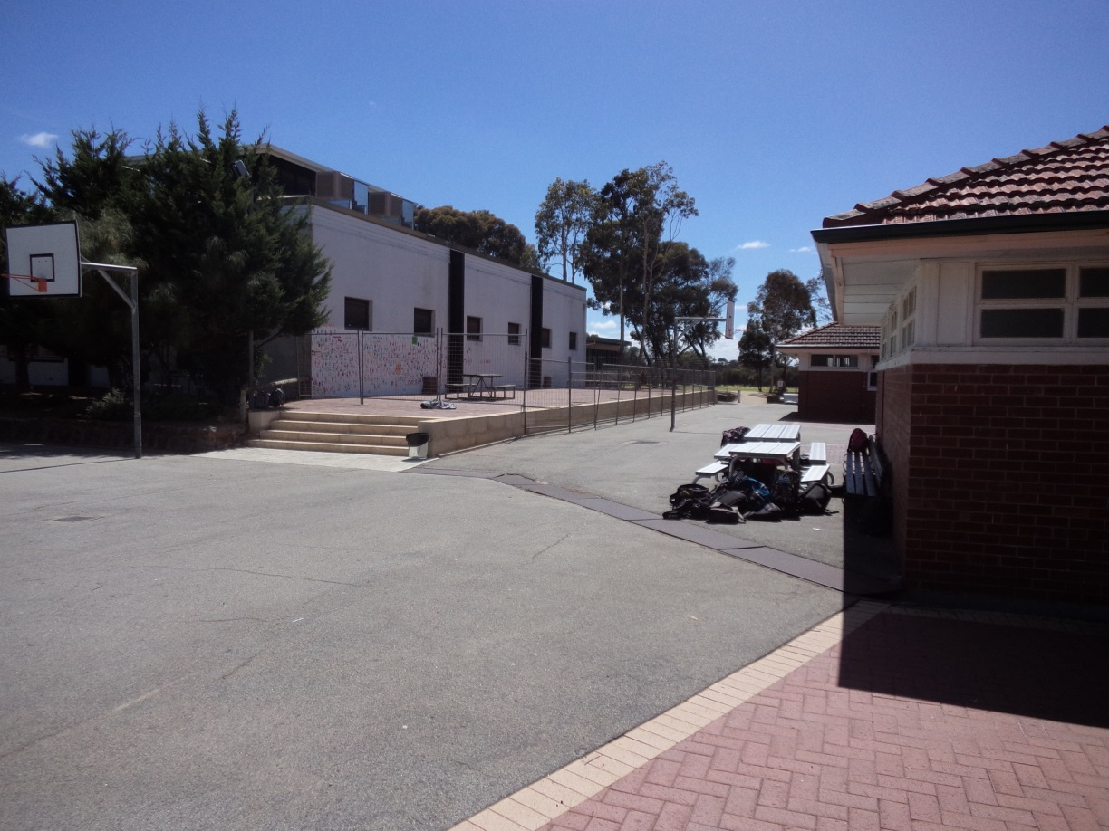
Source 1:
Around 2016

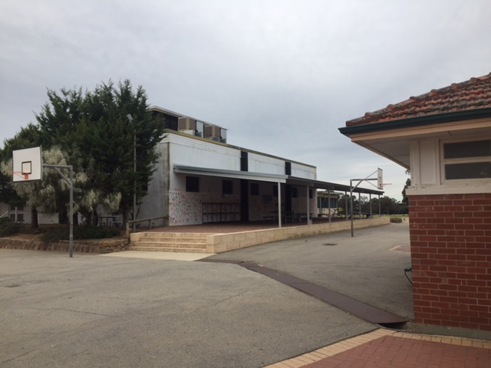

Source 2:
2017

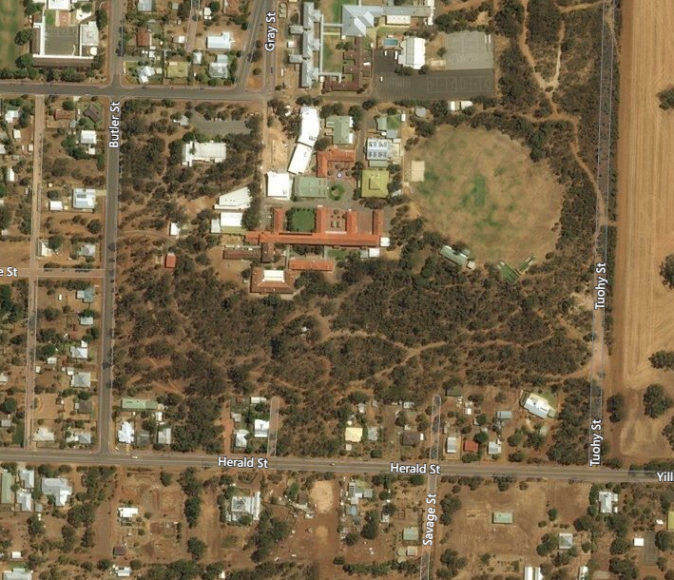
Source 3:

My Map Street View, http://mymapstreetview.com/earth/?t202id=3199&c1=GGS-MyMapST&t202kw=google%20earth&gclid=EAIaIQobChMImNfvyI2k1gIVDr69Ch0k2geYEAAYASAAEgKB5_D_BwE, retrieved on 14/9/17
Source 4:
